Process Design Document – Computer Vision

**UiPath Automation**

**Process Design Document**

**Process Design Document History**

|  |  |  |  |  |  |  |
| --- | --- | --- | --- | --- | --- | --- |
| **Date** | **Version Role** | | **Name** | **Organization** | **Function** | **Comments** |
| 09.01.2021 | 1.0 | Draft | Shailaja,  Julie,  Amita | HSI | Analyst + Developer | Creation v 1.0 |
|  |  | Reviewer | Nisha  Vrinda | HSI | BA | Approval pending  v 1.0 |

### Table of Contents

1. Introduction ……… 4

Purpose of the Document 4

Objectives 4

* 1. Process Key contacts 4

1. AS IS Process Description……………………………………………………………………………………………..5
   1. Process Overview…………………………………………………………………………………………………..5
   2. Detailed Process Map……………………………………………………………………………………………..7
   3. Detailed Process Steps…………………………………………………………………………………………..10
   4. Exceptions handling………………………………………………………………………………………………..13
   5. Error Mapping and Handling…………………………………………………………………………………..16
   6. In-Scope Application Details…………………………………………………………………………………….17
2. Development Details…………………………………………………………………………………………………….18
   1. Prerequisites for Development……………………………………………………………………………………18
   2. Password Policies…………………………………………………………………………………………………….18
   3. Credentials and Asset Management…………………………………………………………………………18
3. Document Approval Flow…………………………………………………………………………………………………18
4. Appendix………………………………………………………………………………………………………………………….19
   1. UiPATH Automated Process Details………………………………………………………………………………19

## **1 Introduction**

## **Purpose of the document**

The Process Design Document describes the business processes chosen for automation using the UiPath Robotic Process Automation (RPA) technology.

This document describes the sequence of steps performed as part of the process, as well as the conditions and requirements prior to its automation. This design document serves as a base documentation for developers to collect the details required for robotic automation of the same business process.

## **Objectives**

The process has been selected for RPA as Project Work for HSI.

The objective of this process automation is mainly to automate the process to

* Connect easily to a remote machine
* Access and store data to local machine.

## **Process key contacts**

The Design Document includes a brief, but comprehensive set of requirements for the process.

|  |  |  |  |
| --- | --- | --- | --- |
| **Role** | **Name** | **Date of action** | **Notes** |
| Reviewer | Nisha, Vrindha | TBD |  |
| Owner | Amita,Julie, Shylaja, | TBD |  |
| Approval for production | Nisha , Vrindha | TBD | Escalations, Delays |

**2 AS IS Process Description**

* + 1. **Process overview**

General information about the process selected for RPA implementation, prior to its automation:

|  |  |
| --- | --- |
| **AS IS process details** | |
| Process full name | Remote Connection |
| Function | Remote Access |
| Department | IT |
| Process short description (operation, activity,outcome) | Connecting to remote machine to access data and storing to local machine. |
| Role required for performing the process | 1 User , 2 systems |
| Process schedule | As and when required |
| # of item processes / day | NA |
| Average handling time per item |  |
| Peak period (s) | No peak period |
| # of FTEs supporting this activity | 3 |
| Level of exception rate | Remote system locked or no internet connection |
| Input data | Client Request |
| Output data | Data scrapped from remote machine |

* + 1. **In scope for RPA**

To enable execution of job on the remote server using the Ui path bot

The objective of this project is to automate

* + - * Sending Authentication Request from the Local Machine to the Remote Machine for Server Connectivity.
      * Authentication Request Approved.
      * Opening an application in remote system and get data from website or some a
      * Calculator – calculate and show result in the Local system
      * Notepad - read text and display on local system
      * Close the connection with the Remote Machine
    1. **Out of scope for RPA**
       - Data Encryption and decryption during data processing.

* 1. **Detailed Process map**

**2.2.1 AS IS Process Diagram**

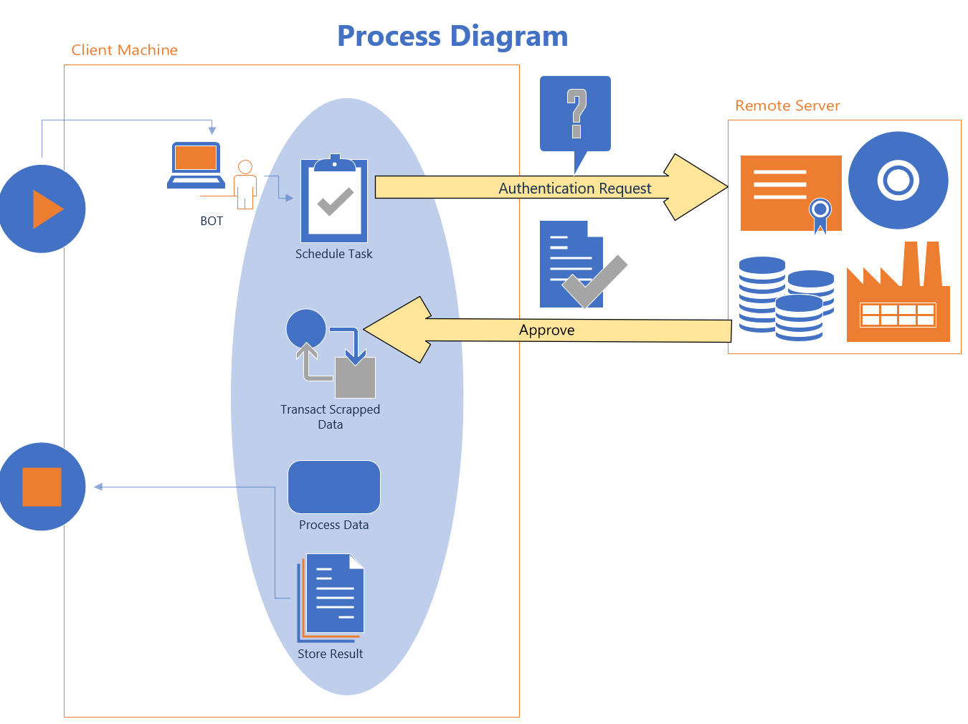

**2.2.2 As -IS Process Description Step by Step in detail**

* + - * Sending Authentication Request to the Remote Machine for Server Connectivity.
      * Authentication Request Approved.
      * Starts Scraping Desktop\Web application based on the requirement.
      * Scrapped data processes.
      * Processed data stored into the local machine.

**2.2.3 To –Be Process Diagram**

This chapter presents the chosen process in detail, which enables the developer to build the automated process.

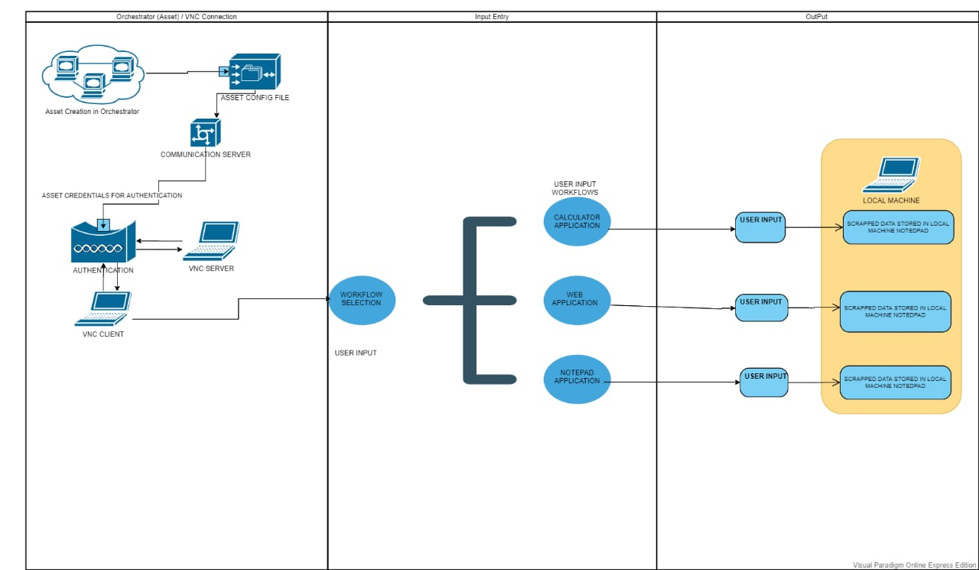

|  |  |
| --- | --- |
| **2.2.4 To – Be Process Steps**  **22** | |
| **1.1** | Open VNC Viewer in Local Machine |
| **1.2** | Select the Team and Select the Remote Machine |
| **1.3** | Enter the Password of Remote machine - Connection established |
| **1.4** | Open the Web/ Notepad/Calculator in the Remote Machine Using CV activities |
| **1.5** | Get the Input from the User – Data to scraped/Notepad file Location/Calculator Input |
| **1.6** | Extract the Data from Web/Notepad/Calculator |
| **1.7** | Display the Extracted Data in the Excel/Output Panel/Message Box |
| **1.8** | Close the Connection |

## **Detailed Process Steps**

The complete set of steps in the process, including keystrokes and clicks, are to be deﬁned with screenshots. If there are any data restrictions, mask the sensitive information, such as Policy Number, Customer ID, bank account number, etc).

|  |  |  |  |  |  |  |  |  |
| --- | --- | --- | --- | --- | --- | --- | --- | --- |
| *#* | | **Step action**  **description** | **Screenshot** | | | **Expected**  **result** | | **Remarks** |
| 1.1 | | Open VNC Viewer in Local Machine |  | | | The display of the VNC Viewer Screen | | Possible exception:  - Handling exception if VNC Viewer not  available |
| 1.2 | | Select the Team and Select the Remote Machine |  | | | Access to the Password window | |  |
| 1.3 | | Enter the Password of Remote machine - Connection established |  | | | Display of the Remote Machine screen in Local Machine | | Possible exception:  - Handling exception if Remote Machine not  available |
| 1.4 | | Open the Web/ Notepad/Calculator in the Remote Machine Using CV activities |  | | | Display of the Web/Notepad/calculator Window in the local machine | | Possible exception:  - Handling exception if Web/Notepad/Calculator not  available |
| **1.5** | | Get the Input from the User – Data to be scraped/Notepad file Location /Calculator Input | | |  | Display of the Specific Web/Notepad/ Calculator Window | | Possible exception:  - Handling exception if Web/ Notepad /Calculator Window not  available | |
| **1.6** | | Extract the Data from Web /Notepad /Calculator | | |  |  | |  | |
| **1.7** | | Display the Extracted Data in the Excel/Output Panel/Message Box | | |  | Display the Output in Excel/ Output Panel/ Message box | | Possible exception:  - Handling exception if Excel /Notepad file Not  available | |
| **1.8** | | Close the Connection | | |  |  | |  | |



## **2.4** **Exceptions Handling**

The types of exceptions identifiable in the automation process can be classified according to the table below

.

|  |  |  |
| --- | --- | --- |
|  | **K** | **Unknown** |
| **Area** | **Known** | **Unknown** |
| **Business** | VNC Viewer – Login Failure – Unknown User Name and Password | Orchestrator Asset Storing Wrong Credentials |
|  | User Input Selection for the Particular Application  Input data for Webscraping/Calculator/Notepad – Invalid Input |  |
| **Application** | Network Not Available  VNC Server is not currently listening for cloud connections | The connection closed unexpectedly.Too many security failures |
|  | Execution Start process failed. | Specified logon session does not exists  It may already have been terminated by the server |
|  | Job not found | Orchestrator connection is lost |
|  | Computer Vision Package not Installed |  |
|  | Application (Webbrowser /Calculator/Notepad) Not Found |  |
|  | Scraped data not available |  |
|  | Data stored was not correct | Storing the scraped data in Local machine – Notepad Application not found |

Based on the above criteria, the table below should reflect all the known exceptions identified throughout the process and map the expected action the robot needs to take in each case.

Insert as many rows as required in the table, to capture all exceptions in a comprehensive list.

|  |  |  |  |  |
| --- | --- | --- | --- | --- |
| # | **Exception Name** | **Step where exception is encountered** | **Parameters** | **Action to be Taken** |
| 1 | Invalid User  Orchestrator not connected  Assets Credential Not valid | Login the VNC Client Viewer  This occurs when you try to start a job on a Robot whose credentials have been incorrectly provided in Orchestrator | Robot does not exists | Enter Valid User Name and Password  Asset Credentials and VNC credentials are not same |
| 2 | System.IO.FileLoadException  System.NullReferenceException  File Not Found Exception | Creating Config Excel File to store the Asset name | Could not Load File or assembly.The Specified Module could not be found | Update all the dll dependencies of the project to latest version.  Check File Path |
| 3 | Connection Failed due to invalid User | Selecting the server for connection | User Name was not recognized or Password is incorrect | If you have a Home subscription, enter the password specified when VNC Server was installed**.** |
| 4 | System.Reflection.TargetInvocationException  System.TypeInitializationException  System.MissingMethodException | If Computer Vision Package not Installed | Exception has been thrown by the target of an invocation | Please uninstall and reinstall the package and then try  Computer Vision can only accept maximum request size of 4 MB or 10 requests per minute |
| 5 | System.NullReferenceException | When the User Gives the Input For Selection of Application and For the Search Type(WebScraping) | Object Reference not set to an instance of an object | Check for Null Or Empty Input  Ask the user again to Select anyone of the Input |
| 6 | Uipath.CV.ElementNotFoundException | When the User gives the Input Data | Element not Found | Ask the User again to Enter a valid data  No Null or white space or Integers be given |
| 7 | System.NullReferenceException   UiPath.CV.ElementNotFoundException  System.Exception   System.ServiceModel.FaultException: An error occurred while sending the request | When the User gives the Input for the Calculator Application | Object Reference not set to an instance of an object  Element not Found | [All CV activities have to be placed inside a CV Screen Scope.](https://docs.uipath.com/activities/docs/introduction)  Computer vision activity is returning null. And other OCR Activity not getting desired result |
| 8 | Uipath.CV.Element NotFoundException  Uipath.Core.SelectorNotFoundException | In Web Scraping Application  While Displaying the Webbrowser  While displaying the Search window  While Scraping the Data from Web  Open the Remote Machine Window | Element not Found  Cannot find the Ui Element corresponding to this selector | Retry scope is used to check for uploding the websearch window  Ask the User to Enter the data again  Or Ask the User to Exit the Program  Close the Connection and Try again |
| 9 | System.NullReference.Exception  Not Found Exception  Empty File or Display Data | In Notepad Application  Users Input Dialog for entry of Filename  Open Notepad on Remote Machine  Open the File in Notepad | Object Reference not set to an instance of an object | Ask User to enter valid string Open File and continue  Terminate the Program  Blank File will be dispalyed , or Data can be seen |
| 10 | System.IO.DirectoryNotFoundException | To store the Scarped Data in an Application in Local Machine | Could not find a Part of the Path | Terminate the Program  Select the Correct Application File Path |

## **Error Mapping and Handling**

A comprehensive list of all the errors, warnings, or notifications should be consolidated here with the description and action to be taken by the Robot in each case.

The errors identified in the automation process can be classified according to the table below.

|  |  |  |
| --- | --- | --- |
| Area | Known | Unknown |
| Application | Network Not Available  VNC Server is not currently listening for cloud connections  Job not found | The connection closed unexpectedly. Too many security failures  Orchestrator connection was lost |

Based on the above criteria, the table below should reflect all the identifiable errors in the process, and map the expected action of the Robot in each case.



Insert as many rows as required in the table, to capture all the errors in a comprehensive list.

|  |  |  |  |  |
| --- | --- | --- | --- | --- |
| **E #** | **Error Name** | **Step where**  **error is encountered** | **Parameters** | **Action to be taken** |
| **1**  **2** | Connection Failed due to invalid User  Orchestrator not connected | Selecting the server for connection  Robot does not exists | User Name was not recognized or Password is incorrect | If you have a Home subscription, enter the password specified when VNC Server was installed**.**  Asset Credentials and VNC credentials are not same |

## **In-Scope application details**

The table below lists all the applications that are used as part of the automated process.

|  |  |  |  |  |  |  |
| --- | --- | --- | --- | --- | --- | --- |
| **#** | **Application name & Version** | **Syst. Lang.** | **Login module** | **Interface** | **Environment/ Access method** | **Comments** |
| 1  2  3  4  5 | UiPath 2010.3 beta 291  VNC Viewer / VNC Server  Web Browser  Calculator  Notepad | EN | Web  Local/Remote  Remote  Remote  Remote | Web  Web  VNC Viewer  VNC Viewer  VNC Viewer | Local Machine  Local Machine/Remote Machine  Web Application  Desktop  Desktop |  |

# **Development details**

## **Prerequisites for development**

� Development or testing environment are to be provided for development purposes.

� The provided development and testing environments are exact replicas of the production environment.

� Dedicated system and application access are given to developers with the adequate permissions.

## **Password policies**

Users manage their own passwords. There are no special policies in place.

## **Credentials and asset management**

#### Login details of VNC Viewer (user IDs and passwords) and VNC server(Password) are stored under UiPath Orchestrator Assets**.**

1. **Document Approval Fl**

|  |  |  |  |  |  |
| --- | --- | --- | --- | --- | --- |
| **Version** | **Flow** | **Role** | **Name** | **Organization (Dept.)** | **Signature and Date:** |
| **1.0** | Document prepared by | Business Analyst | Amita, Julie, Shylaja | HSI |  |
| **1.0** | Document Approved by: | Business Process Owner | Vrindha/Nisha | HSI |  |
| **1.0** | Document Approved by: | Dev/RPA Solution Architect | Vrindha/Nisha | HSI |  |

# **Appendix**

## **UiPath automated processdetails**

**Note: this step is to be ﬁlled in after automation process iscomplete**

**Automation overview**: To Establish connection between Remote and Local Machine and Extract the Data from Remote Machine.

**Robots type**: Unattended

**Level of human intervention required**: Type of Application Selection

**Use of Orchestrator**: Yes

**Exceptions recorded in automation process: Yes**

**Errors identified in the automation process: Yes**

**Challenges identified in the automation process: Connecting Remote and Local Machine**

**Lessons Learned**:

**Any adjustments** made to facilitate the automation process and any steps taken to shift from the human way of working to the automatic one. Any activity performed to improve the As Is process and to enable higher rates of automation of the process:

➢ Automation of Connection between Remote and Local Machine

➢ Automation of getting the credentials from Orchestrator

➢ Automation of data extraction from remote machine and Storing the output in Local Machine

R**eporting:** The details and format of the logging mechanism available in the workflow have to be specified here, whether it is a local log report or the Orchestrator log – Orchestrator Log

**Workflow and Scripts:** A brief overview of each workflow and the sequence in which it is executed should be provided here.

**InitAllSettings.Xaml -** Initialize, populate and output a configuration Dictionary to be used throughout the project. Settings and constants are read from the local configuration file, and assets are fetched from Orchestrator. Asset values overwrite settings and constant values if they are defined with the same name.

**GetAppCredentials.Xaml -** Securely fetch or create and use a set of credentials. First, there is an attempt to fetch credentials from Orchestrator using the name received as argument. If it is not possible to retrieve those credentials from Orchestrator, there is an attempt to fetch them from the Windows Credential Manager (WCM). If the credentials are not defined in the WCM, the user is prompted to create the credentials that will be added to the WCM and returned for use during the process execution**.**

**VNC_Client.Xaml –** Credentials will be entered into the Sign In window of VNC Client. Remote Machine (Server) will be selected. Authentication request will be sent to the Remote Machine. Once approved connection will be established.

**CV_CalculatorApp.Xaml –** To open the Calculator App in the Remote machine. Mathematical expression will be entered and Result will be extracted**.**

**CV_Notepad_Scrapping.Xaml -** To open the Notepad App in the Remote machine. File Location will be entered and the contents in the particular file will be extracted.

**CV_WebScrapping.Xaml -** To open the Web Browser in the Remote machine. Serach data will be entered and Result will be extracted

**GetNotepad.Xaml –** To Open the Notepad App in the Local Machine. Extracted Result will be Stored in the file.

**CloseConnection.Xaml –** To Close the Remote Connection and to Sign out from the Client.